Important Notes for Institute of Technology Law, Master Degree and In-Service Program Leavers

After completing your graduation oral, you can perform the following procedures

1. Print your thesis
(a) Before binding your thesis, please show to your Major Professor. After receipt of your Head of Department signed approval, have it bound.
(b) Papers to be bound as per “dissertation format”
(c) The cover should be of colored paper. Use same color for the same class. (The Institute of Technology Law has its own color – refer to annexed file, pay attention before printing)

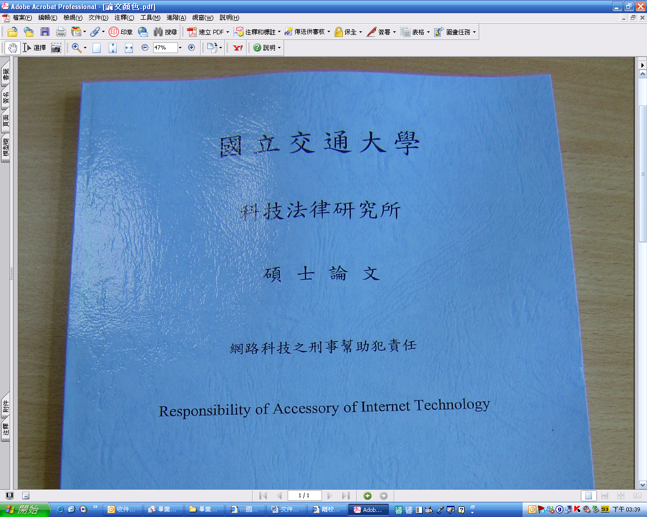

2. Go to National Yang Ming Chiao Tung University Institute of Technology Law Master and Doctoral Theses System
http://www.lib.nctu.edu.tw/etd/ and upload full text.
Print these electronic files access authorization and have it bound with the thesis (According to National Yang Ming Chiao Tung University Master degree and Doctoral degree Operating Regulations Article 12, since Year 2001 every graduates must file his full-text thesis on the Internet.

3. Go to“Leavers page http://aadms.nctu.edu.tw/Graduate/”and complete the procedure
(a) Remit three copies of your thesis to the Department’s Office (one for The Registrar’s Office, one for Hao-Ran Library, one for the Department’s records)
(b) Remit the National Yang Ming Chiao Tung University electronic thesis approval notice
(c) Remit the Leaver’s consent - Graduated
(d) Remit to the National Library the Master and Doctoral Thesis electronic file access authorization
(e) Please send by yourself a copy to each of the Oral Assessment committee member
(f) Remit back all borrowed items such as access control card and so on
(g) After finishing these leaving procedures, take your student ID and go to the Registrar Office to collect diploma.

